**Annexure3b- Complete filing**

**INVENTION DISCLOSURE FORM**

Details of Invention for better understanding:

1. **TITLE:** Emotion-Based Spending Analysis & Alerts
2. **INTERNAL INVENTOR(S)/ STUDENT(S):** All fields in this column are mandatory to be filled

|  |  |
| --- | --- |
| A. Full name | Bhavya Jain |
| Mobile Number | 7733913593 |
| Email (personal) | jainbhavya2114@gmail.com |
| UID/Registration number | 12306024 |
| Address of Internal Inventors | Lovely Professional University, Punjab-144411, India |
| Signature (Mandatory) |  |

|  |  |
| --- | --- |
| B. Full name | Ayush Raj |
| Mobile Number | 9060666041 |
| Email (personal) | [itzayush.2721@gmail.com](mailto:itzayush.2721@gmail.com) |
| UID/Registration number | 12308724 |
| Address of Internal Inventors | Lovely Professional University, Punjab-144411, India |

|  |  |
| --- | --- |
| Signature (Mandatory) |  |

|  |  |
| --- | --- |
| C. Full name | Sri ragavan |
| Mobile Number | 7904403415 |
| Email (personal) | [sriragavandhandapani@gmail.com](mailto:sriragavandhandapani@gmail.com) |
| UID/Registration number | 12301363 |
| Address of Internal Inventors | Lovely Professional University, Punjab-144411, India |
| Signature (Mandatory) |  |

## (FOR ADDITIONAL INVENTORS, PLEASE ADD ROWS)

1. **DESCRIPTION OF THE INVENTION:** This invention proposes an AI-powered financial assistant designed to analyze emotional and behavioral patterns to mitigate impulse spending. The system utilizes multi-modal AI techniques, incorporating facial recognition, voice tone analysis, typing speed monitoring, and behavioral tracking to detect emotional states influencing purchasing decisions.

The system collects real-time user data, including facial expressions, voice variations, browsing patterns, transaction history, and typing behaviors. Using advanced machine learning algorithms, it identifies emotional triggers such as stress, excitement, fatigue, or boredom that may lead to impulsive purchasing. Upon detection, the AI intervenes with real-time alerts, spending restrictions, and delayed checkout mechanisms to encourage mindful financial decisions.

Additionally, the system provides long-term spending insights through interactive dashboards and emotion-based financial reports. Features such as emotional spending analytics, personalized budgeting recommendations, and alternative financial habit suggestions empower users to develop healthier spending behaviors. The AI continuously refines its intervention strategies based on historical data, ensuring customized and effective impulse control for each user. By enabling real-time emotional awareness in financial decision-making, this invention enhances financial well-being and consumer self-regulation. The integration of AI-driven emotional analysis with financial tracking ensures a novel and practical approach to responsible spending management, optimizing both short-term purchase behavior and long-term financial planning.

### Motivation and Advantages

Impulse spending and emotional-based purchases present significant financial challenges for individuals, often leading to regret, financial strain, and difficulty maintaining a budget. Existing financial management tools primarily focus on transaction tracking, budgeting, or automated savings but fail to address the underlying emotional triggers that drive impulsive purchases. Many individuals struggle with self-regulation when emotions such as stress, excitement, fatigue, or boredom influence their spending behavior. This invention introduces an AI-powered Emotion-Based Spending Analysis & Alerts System that actively detects and mitigates impulse buying by analyzing real-time emotional and behavioral cues. Unlike traditional financial tracking solutions, this system leverages multi-modal AI—incorporating facial recognition, voice tone analysis, and typing behavior—to detect emotional states that may contribute to unplanned spending. By integrating real-time alerts, checkout delays, and alternative financial suggestions, the system provides users with instant interventions designed to promote mindful spending. Furthermore, the AI-driven spending insights feature offers users a personalized understanding of their emotional triggers over time, allowing them to build healthier financial habits. The system also supports long-term financial wellness by suggesting alternative financial strategies, such as saving challenges, goal-based spending, and guided financial coaching. With its proactive approach, this innovation empowers individuals to take control of their finances by aligning their spending habits with their financial goals, ultimately fostering responsible and intentional purchasing behavior.

## TECHNICAL WORKING

The *Emotion-Based Spending Analysis & Alerts System* operates through a sophisticated AI-driven framework that integrates real-time emotional detection, behavioral analysis, purchase intervention mechanisms, and adaptive financial insights to enhance user spending awareness and decision-making. The system begins by acquiring user data through multiple modalities, including facial expression recognition via a webcam or smartphone camera, voice tone analysis from microphone input, and typing behavior assessment while browsing or making transactions online. It continuously monitors browsing behavior, cart additions, and purchase attempts to detect potential impulse-buying tendencies. Once the system gathers data, it employs deep learning models to analyze emotional states such as stress, excitement, fatigue, and boredom, correlating these emotions with spending behaviors. By assessing these emotional patterns, the AI can determine whether a purchase is likely to be driven by impulse rather than necessity. If the system identifies a high-risk emotional spending scenario, it triggers real-time intervention strategies, such as displaying warning messages, delaying checkout for a short period, or suggesting alternative financial behaviors. The delayed checkout feature acts as a psychological buffer, encouraging users to reflect on their purchase decisions rather than proceeding immediately out of impulse. Over time, the system adapts to the user’s financial habits by tracking spending patterns and generating personalized insights. It provides users with emotion-based spending reports, highlighting trends and identifying recurring triggers that lead to unplanned expenditures. Additionally, the AI suggests budgeting strategies tailored to the individual’s emotional profile, helping them develop healthier financial habits. To further encourage responsible spending, the system offers AI-guided financial challenges, such as rewarding users for delaying unnecessary purchases or setting emotional-spending limits. The entire process is supported by continuous performance analytics, where machine learning models refine emotional detection accuracy and improve intervention strategies based on user responses. Through an interactive dashboard, users can review their emotional spending trends, receive financial coaching recommendations, and adjust their spending goals. By leveraging advanced multi-modal AI, the system ensures a proactive and personalized approach to financial wellness, empowering users to make more intentional and informed purchasing decisions.

### User Data Acquisition

The system collects real-time user data to assess emotional states and spending behaviors for impulse purchase prevention.

### Key Data Sources:

* + **Facial Expression Analysis:**
    - AI detects stress, excitement, fatigue, and boredom via micro-expressions and muscle movements.

### Voice & Speech Recognition:

* + - AI detects stress, excitement, fatigue, and boredom via micro-expressions and muscle movements.

### Typing & Interaction Patterns:

### Tracks typing speed and browsing behavior to detect impulsive or hesitant purchasing actions.

### Spending History & Intent:

### Analyzes past transactions and shopping habits to identify emotional spending patterns.

### Behavioral Insights:

### Continuously refines spending analysis to provide personalized interventions and adaptive alerts.

### AI-Driven Emotional & Spending Behavior Analysis

The system uses machine learning to detect emotional spending triggers and deliver personalized interventions.

### AI Algorithms Used:

* + **Natural Language Processing (NLP) & Sentiment Analysis:**
    - AI analyzes voice tone and text to detect stress, excitement, or frustration behind purchases.
* **Behavioral Clustering:**
  + - Groups users by spending habits and emotional triggers to enable targeted financial interventions.

### Real-Time Adaptive Matching:

* + - Continuously refines emotional detection and spending alerts based on user history.

### Real-Time Interview & Mentorship Execution

Once emotional spending is detected, the system provides real-time interventions through an interactive interface.

### Key Features:

* + **Spending Alerts & Warnings:**
    - Notifies users of emotional spending triggers with personalized prompts.

### Checkout Delay Mechanism:

* + - Temporarily locks purchases to encourage mindful decision-making.

### Alternative Financial Suggestions:

* + - Recommends saving, budgeting, or investment options instead of impulsive purchases.

### Structured Feedback & Adaptive Learning

Post-purchase analysis helps users understand emotional spending patterns and improve financial habits.

### Feedback Mechanisms:

* + **AI-Generated Spending Reports:**
    - Evaluates purchases based on emotional triggers, spending frequency, and behavioral trends.

### User Reflection Prompts:

* + - Encourages users to review and rate purchases to enhance financial awareness.

### Adaptive Learning Recommendations:

* + - Suggests budgeting strategies and alternative spending habits based on past behavior.

### Performance Analytics & Insights

The system converts spending data into actionable insights to improve financial decision-making.

### Visualization Tools Used:

* + **Personalized Dashboards:**
    - Displays emotional spending trends, triggers, and budgeting progress.

### AI-Based Spending Patterns:

* + - Identifies frequent impulse purchases and high-risk emotional triggers.

### Trend Analysis Reports:

* + - Tracks long-term spending behavior to recommend smarter financial habits.

### Security, Deployment & Scalability

The system is designed for secure, scalable, and seamless financial monitoring across users. Key Features:

### End-to-End Encryption:

* + - Protects user data and ensures privacy in emotional and spending analysis.

### Cloud-Based Architecture (AWS, Azure, GCP):

* + - Supports real-time processing and large-scale deployment across devices.

### API Integration:

* + - Connects with banking apps, budgeting tools, and financial wellness platforms.

### Unique Attributes and Advantages:

* + **AI-Driven Emotional Spending Detection:** Leverages facial recognition, voice tone, and typing patterns to detect stress, excitement, or boredom, preventing impulse purchases in real time.
  + **Real-Time Adaptive Interventions:** Uses machine learning to analyze user behavior, refining spending alerts and interventions dynamically for more personalized financial control.
  + **Personalized Financial Insights:** Tracks emotional spending patterns, generates AI-driven reports, and recommends budgeting strategies tailored to the user’s financial habits.
  + **Customizable Spending Controls:** Allows users to set spending limits, enable checkout delays, and receive targeted alerts, helping them make mindful purchasing decisions.
  + **Secure & Scalable Architecture:** Cloud-based deployment ensures seamless integration with financial apps while maintaining user privacy through end-to-end encryption.
  + **Continuous Learning & Smart Recommendations:** AI evolves with user spending behavior, offering adaptive insights and proactive financial guidance for long-term financial well-being.

## 6. PROBLEM ADDRESSED BY THE INVENTION

Traditional budgeting tools and financial apps fail to recognize the emotional triggers behind impulse spending, leading to ineffective spending control. Users often make purchases driven by stress, excitement, or boredom without real-time interventions to curb impulsive behavior. This invention introduces an AI-driven system that detects emotional spending patterns, provides adaptive interventions, and delivers personalized financial insights, ensuring smarter and more mindful purchasing decisions.

### AI-Driven Emotional Spending Detection

* + The system analyzes facial expressions, voice tone, and typing behavior to identify emotional triggers behind spending decisions.
  + Unlike traditional budgeting tools, this invention provides real-time AI-driven interventions to prevent impulse purchases based on emotional states.
  + Users receive personalized alerts and spending insights, ensuring mindful financial decisions aligned with their long-term goals.

### Structured Feedback for Spending Awareness

* + The system generates AI-driven reports analyzing emotional triggers, spending patterns, and decision-making tendencies.
  + Real-time insights help users recognize impulse spending habits and refine their financial discipline over time.
  + Personalized alerts and recommendations ensure continuous improvement in budgeting and mindful purchasing behavior.

### Real-Time Spending Behavior Analysis & Alerts

* + Many users struggle to recognize emotional triggers behind impulsive spending, leading to financial instability.
  + This system continuously analyzes spending behavior, detecting stress, excitement, or fatigue-driven purchases in real time.
  + Unlike traditional budgeting tools, it provides adaptive alerts and interventions based on evolving financial habits, ensuring smarter decision-making.

### Intelligent Spending Analytics for Financial Wellness

* + The system tracks emotional spending patterns over time, using adaptive AI to recommend personalized budgeting strategies.
  + Interactive dashboards provide insights into spending triggers, trends, and financial habits, helping users make informed decisions.
  + AAI-powered analysis refines financial recommendations, ensuring users develop long-term, mindful spending behaviors.

### Scalable and Accessible Financial Guidance

* + Traditional financial tools fail to provide real-time emotional spending insights, limiting accessibility to proactive budgeting support.
  + This invention offers scalable, cost-effective emotional spending analysis and intervention, helping users control impulse purchases effortlessly.
  + Cloud-based deployment ensures seamless integration with financial apps, making spending awareness accessible anytime, anywhere.

### Enhancing Financial Awareness and Smart Spending

* + The platform focuses on bridging skill gaps by ensuring structured, data-driven interview preparation for individuals across industries.
  + AI-driven career mapping tools suggest relevant practice areas, mentorship sessions, and skill development plans based on industry trends.
  + Reduces hiring challenges for companies by producing better-prepared candidates, improving employability and professional growth.

## OBJECTIVE OF THE INVENTION

### AI-Driven Smart Interview Pairing

This invention enhances interview preparation by leveraging real-time AI-driven pairings to match users for mock interviews. By analyzing skill levels, learning objectives, and prior experiences, the system ensures effective and relevant interview practice sessions. Unlike traditional methods that rely on manual scheduling, this AI-powered approach optimizes pairings dynamically, helping users improve communication skills and gain confidence in technical and behavioral interviews.

### Structured Feedback for Real-Time Spending Awareness

The system provides instant spending reviews with AI-generated insights on emotional triggers and purchasing behavior. By analyzing voice tone, facial expressions, and transaction patterns, it tracks impulsive spending tendencies and offers personalized financial recommendations. Users receive structured feedback through AI-driven alerts and spending reports, enabling continuous improvement in financial decision-making.

### AI-Powered Spending Guidance

The system provides personalized financial guidance by analyzing user spending habits and emotional triggers. AI-driven recommendations help users make informed purchasing decisions, avoid impulse spending, and develop better financial habits. Unlike traditional budgeting tools, this platform adapts spending advice based on real-time behavior, ensuring continuous and relevant financial support.

### AI-Driven Emotional Spending Detection

Using advanced machine learning models, the system analyzes user emotions, past spending behavior, and transaction patterns to detect impulse purchases. The AI clusters users based on emotional triggers and financial habits, ensuring real-time interventions tailored to their spending tendencies. This intelligent detection system enhances financial awareness, promoting mindful and controlled spending decisions.

### Continuous Learning & Adaptive Spending Insights

The AI-powered system tracks user spending behavior over time, refining emotional detection and intervention accuracy. Interactive dashboards provide real-time financial insights, helping users identify impulsive spending patterns and emotional triggers. The system continuously adapts recommendations based on spending trends, ensuring long-term financial stability through personalized guidance.

1. **STATE OF THE ART/ RESEARCH GAP/NOVELTY:**

|  |  |  |  |  |
| --- | --- | --- | --- | --- |
| Sr. No. | Patent I’d | Abstract | Research Gap | Novelty |
| 1 | US20230145363A1 | Describes a financial monitoring system that analyzes transaction data and provides spending recommendations based on historical patterns. | 1. 1. Focuses on historical spending patterns but does not incorporate real-time emotional state analysis. 2. Does not integrate multimodal AI (voice, facial, typing speed) for detecting spending triggers. 3. Lacks AI-based interventions such as checkout delays or spending warnings based on emotions. | 1. AI-driven multimodal emotional analysis for real-time spending interventions. 2. Smart alerts and transaction controls triggered by stress, excitement, or fatigue. 3. Delayed checkout feature to prevent impulse buying. |

|  |  |  |  |  |
| --- | --- | --- | --- | --- |
|  |  |  |  |  |
| 2 | US20220122191A1 | Describes an AI-based recommendation system that suggests financial strategies based on user behavior and predefined spending habits. | 1. 1. Focuses on behavior-based spending but lacks real-time emotional detection. 2. No integration of voice, facial, and behavioral cues for financial decision-making. 3. Lacks AI-based adaptive learning to track emotional spending patterns over time. 4. Does not provide personalized interventions to guide users towards healthier financial habits. | 1.AI-powered financial assistant that monitors real-time emotional states during spending. 2. Emotion-driven spending insights with adaptive learning. 3. AI-generated spending alerts based on emotional triggers. 4. Personalized financial coaching mode based on detected emotional patterns. |
| 3 | |  | | --- | |  |  |  | | --- | | US12008579B1 | | Describes a fraud detection system using an emotion-based deep learning model that analyzes customer communications to identify potential fraudulent activities. | 1. Focuses on fraud detection rather than assisting users in managing their own spending habits. 2. Analyzes emotions in customer communications but does not monitor user behavior during transactions | 1. AI-powered financial assistant that monitors user's emotional state during transactions to detect potential impulse purchases. 2. Real-time alerts and interventions to help users make more informed spending decisions. |

|  |  |  |  |  |
| --- | --- | --- | --- | --- |
|  |  |  | 3. Lacks real-time intervention to prevent impulsive financial decisions by users. | 3. Integration of multi-modal emotion detection (voice tone, typing speed, facial expressions) for comprehensive analysis. |

# DETAILED DESCRIPTION:

The proposed invention is an AI-powered emotional spending analysis and intervention system designed to prevent impulse purchases through real-time detection and adaptive financial guidance. Unlike traditional budgeting tools, this system dynamically analyzes user emotions, spending behaviors, and transaction patterns using AI-driven facial recognition, voice analysis, and typing behavior tracking. By providing instant interventions and personalized financial insights, the platform ensures smarter spending decisions and long-term financial well-being.

### AI-Powered Emotional Spending Detection

The platform utilizes advanced AI algorithms to analyze user emotions, spending patterns, and behavioral triggers, enabling real-time interventions to prevent impulse purchases.

* + Machine learning models (facial recognition, NLP-based sentiment analysis) assess stress, excitement, and urgency linked to emotional spending.
  + Real-time adaptive monitoring ensures users receive instant alerts and personalized financial guidance based on detected spending triggers.
  + Users can customize intervention settings to align with their financial goals, ensuring a personalized and effective spending control experience.

### Real-Time AI-Driven Spending Intervention

The platform delivers instant, AI-powered alerts and guidance to prevent emotional spending through an intuitive, real-time interface.

* + Provides real-time notifications based on facial expressions, voice tone, and spending behavior, helping users make informed purchasing decisions.
  + Ensures seamless integration with banking apps and e-commerce platforms, offering adaptive financial recommendations and budget-friendly alternatives.
  + Features interactive dashboards and spending insights to help users track emotional triggers and develop better financial habits over time.

### AI-Driven Feedback for Spending Awareness

The system provides structured insights to help users recognize emotional spending patterns and improve financial decision-making.

* + AI-generated reports analyze purchase behavior, emotional triggers, and spending frequency to offer personalized financial advice.
  + Users receive real-time alerts and recommendations based on historical data, guiding them toward better spending habits.
  + Peer and AI-driven reviews help users reflect on impulsive purchases, fostering continuous financial awareness and control.

### AI-Driven Spending Behavior Analysis

The system utilizes advanced analytics to identify emotional spending triggers and provide personalized financial recommendations.

* + Tracks user spending habits, emotional states, and transaction patterns to detect impulsive purchase behavior.
  + AI-driven insights suggest budgeting strategies, spending limits, and alternative actions to encourage mindful financial decisions.
  + Predictive analytics refine recommendations over time, ensuring adaptive and personalized financial management.

### Personalized Spending Controls & Alerts

The system allows users to customize financial limits and receive real-time alerts to prevent impulsive spending.

* + Enables users to set personalized spending thresholds, category-based restrictions, and financial goals.
  + AI monitors transactions and browsing behavior to trigger alerts when potential impulsive purchases are detected.
  + Adaptive notifications provide alternative suggestions, promoting mindful spending habits and financial discipline.

### Session Recording and Performance Insights

The platform enables users to review past interactions for self-improvement and targeted skill enhancement.

* + AI-powered session recordings and transcripts help users analyze communication patterns, technical responses, and confidence levels.
  + Sentiment analysis and speech recognition highlight areas needing improvement, refining interview techniques over time.
  + Timestamped feedback summaries allow users to revisit critical moments for focused learning and progress tracking.

### Secure and Anonymous Mode

The platform ensures user privacy and security through encrypted communication and anonymous participation options.

* + Users can opt for anonymous pairing, allowing practice sessions without disclosing personal details.
  + End-to-end encryption safeguards all interactions, ensuring confidentiality and data protection.
  + AI-powered moderation monitors sessions to maintain a safe, professional, and ethical interview environment.

# Results and Advantages of the AI-Powered Emotion-Based Spending Analysis & Alerts

### Results Achieved:

1. **Enhanced Spending Awareness:**
   * Users gain real-time insights into their emotional triggers while making purchases.
   * AI-driven alerts help prevent impulsive decisions, leading to more mindful spending habits.

### Intelligent Emotion & Purchase Detection:

* + AI analyzes facial expressions, voice tone, and typing speed to detect emotional spending patterns.
  + Real-time interventions reduce unnecessary expenses and encourage financial discipline.

### Smart Spending Alerts & Controls:

* + Personalized notifications warn users about stress-induced or excitement-driven purchases.
  + Features like checkout delays and alternative financial suggestions promote better decision-making.

### Long-Term Financial Insights:

* + Emotion-based spending reports help users recognize patterns and adjust their budgeting strategies.
  + AI-generated insights enable personalized financial planning and improved money management.

### Improved Financial Well-Being:

* + Users develop healthier spending habits, reducing regretful purchases and financial stress.
  + Encourages mindful spending, leading to better savings and investment decisions.

### Advantages Over Existing Prior Art:

|  |  |  |
| --- | --- | --- |
| **Feature** | **Existing Systems** | **AI-Powered Random Pairing Platform** |
| **Emotion & Behavior Detection** | Limited to transaction history & spending patterns | Uses **multi-modal AI** (voice tone, facial expressions, typing speed, and behavior analysis) for **real-time emotional monitoring** |
| **Impulse Purchase Prevention** | Relies on **basic budget alerts** or spending limits | Detects **emotional triggers** (stress, excitement, boredom, fatigue) and **intervenes before purchase** |
| **Real-Time Warnings & Interventions** | No **emotional intelligence-based alerts** | AI provides **real-time emotional warnings, delayed checkout options, and alternative spending suggestions** |
| **Integration with Smart Wearables** | Rarely includes biometric data for spending insights | Uses **heart rate & stress levels** from smartwatches to enhance emotional detection accuracy |
| **Long-Term Financial Insights** | Provides **general spending reports** based on category and frequency | Generates **emotion-based spending reports** and suggests **personalized budgeting strategies** |
| **User-Controlled Customization** | Fixed budget tracking with limited personalization | Users can **set personal spending goals** and adjust AI interventions **based on emotional spending triggers** |

**Superiority Over Prior Art:**

* **Real-Time Emotion-Based Spending Alerts:** Unlike traditional budgeting apps that track past expenses, this AI-driven system detects emotional triggers in real time and intervenes before impulsive purchases occur.
* **Multi-Modal AI Analysis:** Combines facial recognition, voice tone analysis, and typing behavior to assess user emotions, ensuring a highly accurate spending analysis system.
* **Behavioral Spending Intervention:** Instead of just providing spending insights, the system actively prevents impulsive purchases through checkout delays, alerts, and alternative financial suggestions.
* **Continuous Learning & Adaptation:** Tracks long-term spending behavior refining its emotional analysis and intervention strategies for each user.
* **Scalable & Versatile Application:** Can be integrated with banking apps, e-commerce platforms, and personal finance tools to provide a comprehensive financial wellness solution.

This innovation revolutionizes financial decision-making by offering proactive, AI-driven emotional spending management, bridging the gap between budgeting and behavioral psychology.

## EXPANSION:

To ensure scalability and adaptability, the proposed AI-powered emotion-based spending analysis system considers multiple dynamic variables that influence financial decision-making, emotional triggers, and impulsive spending patterns. These variables enable the system to continuously refine emotional detection accuracy, enhance spending interventions, and optimize financial wellness recommendations over time.

### User Demographics and Spending Behavior

* + Emotional Spending Triggers: Categorizes users based on stress, excitement, boredom, or fatigue-related spending habits, ensuring personalized financial interventions.
  + Spending Patterns & Categories: Analyzes user purchase behavior (retail, food delivery, subscriptions, etc.) to detect high-risk spending areas.
  + User Engagement & Financial Goals: Tracks spending frequency, impulse purchase trends, and savings objectives to refine AI-driven spending alerts.

### Emotional Spending Analysis and Financial Guidance Variables

* + Spending Alert Sensitivity: Adjusts AI intervention frequency based on user spending behavior, preventing unnecessary or excessive alerts.
  + Financial Expert Insights: Provides AI-driven budgeting advice and spending control strategies based on real-world financial coaching principles.
  + Adaptive AI Recommendations: Continuously refines spending alerts and financial guidance based on user feedback and historical spending patterns.

### Real-Time Spending Feedback and Behavioral Analytics

* + Emotion-Based Spending Alerts: AI analyzes emotional triggers (stress, excitement, fatigue) and provides instant alerts before impulsive purchases.
  + Spending Pattern Analysis: Tracks transaction history, purchase frequency, and emotional states to identify risky spending habits.
  + Decision Impact Measurement: Evaluates how AI interventions influence spending behavior, ensuring long-term financial mindfulness and control.

### AI-Driven Adaptive Spending Controls

* + Behavioral Pattern Recognition: Uses machine learning models to detect spending habits based on emotional states and transaction history.
  + Dynamic Purchase Delay Mechanism: AI intervenes by temporarily pausing impulsive transactions, allowing users time to reconsider.
  + Smart Budgeting Adjustments: Users receive AI-driven spending recommendations, adapting financial goals based on real-time behavioral insights.

### Accessibility and Platform Integration Variables

* + Multi-Device Compatibility: Ensures seamless functionality across mobile, desktop, and wearable devices for real-time spending analysis.
  + Integration with Banking & Budgeting Apps: Syncs with financial tools to provide AI-driven spending alerts and emotional spending insights.
  + Customizable User Preferences: Allows users to set personalized spending limits, trigger alerts, and adjust AI intervention levels based on financial goals.

## WORKING PROTOTYPE/ FORMULATION/ DESIGN/COMPOSITION:

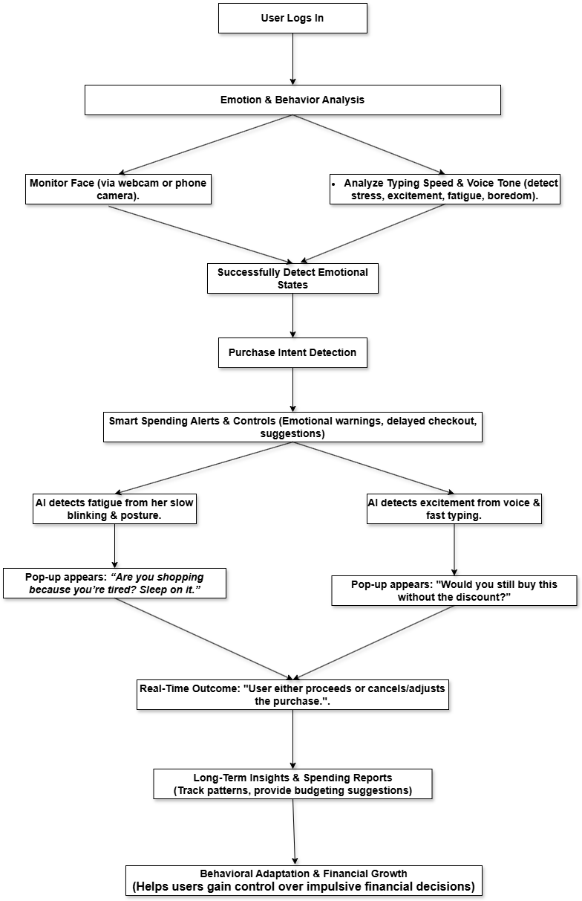

1. Fig 1: AI-Driven Emotion-Based Spending Analysis & Alerts

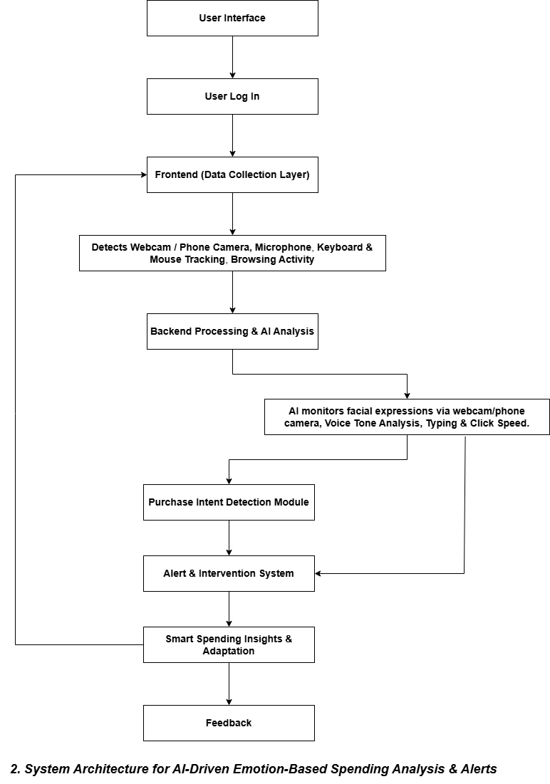

## EXISTING DATA:

Several studies and patent filings have been analyzed to assess the effectiveness of AI-powered emotional spending analysis and intervention systems compared to traditional budgeting tools. The following patents and research initiatives provide insights into the current landscape of AI-driven financial behavior monitoring and impulse spending control:

## US10593350B2

**Title:** Quantifying Customer Care Utilizing Emotional Assessments

* + This patent outlines a system that assesses customer emotions to quantify customer care experiences.
  + It focuses on evaluating customer interactions to improve service quality.
  + The system analyzes emotional cues during customer service interactions to provide insights into customer satisfaction.

### Relevance to This Invention:

* + While this system assesses customer emotions, it is primarily aimed at enhancing customer service experiences.
  + It does not focus on real-time detection of consumer emotions during online shopping or provide interventions to prevent impulse purchases. c)Our invention differs by actively monitoring user emotions during online transactions and providing immediate alerts to mitigate impulsive spending.

## US20230162214A1

**Title:** System and Method for Predicting Impact on Consumer Spending Using Machine Learning

* + This patent describes a system that uses machine learning to predict the economic impact of negative customer experiences.
  + It focuses on analyzing feedback data to forecast how negative experiences affect consumer spending.
  + The system generates decision trees to compute the economic impact of various negative customer experiences.

### Relevance to This Invention:

* + This system predicts spending behavior based on past negative experiences but does not monitor real-time emotional states during transactions.
  + It lacks mechanisms to detect emotions like stress or excitement during online shopping sessions.
  + Our invention proactively analyzes real-time emotional cues to alert users before they make impulse purchases, addressing a different aspect of consumer spending behavior.

## US11694257B2

**Title:** Utilizing Artificial Intelligence to Make a Prediction About an Entity Based on User Sentiment and Transaction History

* + This patent involves using AI to predict outcomes related to entities (e.g., companies) based on user sentiment and transaction history.
  + It analyzes sentiment data to forecast metrics like stock prices or company performance.
  + The system provides recommendations or actions based on the predicted outcomes.

### Relevance to This Invention:

* + While it utilizes sentiment analysis, this system is geared towards predicting external entity performance rather than individual consumer spending behavior.
  + It does not focus on detecting a user's emotional state during personal spending activities or provide interventions to influence their purchasing decisions.
  + Our invention specifically targets real-time monitoring of user emotions during online shopping to prevent impulsive spending, offering a unique application of emotion detection technology.

## USE AND DISCLOSURE (IMPORTANT):

|  |  |  |
| --- | --- | --- |
| A. Have you described or shown your invention/design to anyone or in any conference? | YES ( ) | NO ( √ ) |
| B. Have you made any attempts to commercialize your invention (for example, have you approached any companies about purchasing or manufacturing your invention)? | YES ( ) | NO ( √ ) |
| C. Has your invention been described in any printed publication, or any other form of media, such as the Internet? | YES ( ) | NO ( √ ) |
| D. Do you have any collaboration with any other institute or organization on the same? Provide name and other details. | YES ( ) | NO ( √ ) |
| E. Name of Regulatory body or any other approvals if required. | YES ( ) | NO ( √ ) |

1. Provide links and dates for such actions if the information has been made public (Google, research papers, YouTube videos, etc.) before sharing with us.

Not Shared

1. Provide the terms and conditions of the MOU also if the work is done in collaboration within or outside university (Any Industry, other Universities, or any other entity).

N/A (No collaboration)

## POTENTIAL CHANCES OF COMMERCIALIZATION

The AI-powered emotion-based spending analysis and alert system has significant commercialization potential, offering scalable and adaptable solutions for financial wellness, impulse control, and consumer behavior analysis. The platform’s unique AI-driven real-time emotional detection makes it valuable for banks, fintech companies, e-commerce platforms, personal finance apps, and digital.

### Growing Demand for AI-Powered Financial Wellness Solutions

* + With the increasing reliance on digital payments and online shopping, managing impulse spending has become a critical challenge for consumers.
  + Traditional budgeting apps and financial advisory services lack real-time emotional awareness, leading to ineffective impulse control.
  + Banks, fintech companies, and e-commerce platforms are seeking AI-driven solutions that help users make mindful financial decisions by integrating emotion-based spending analysis into their services.

### AI-Driven Financial Coaching for Businesses and Employees

* + Corporations and financial institutions are investing in AI-powered financial wellness programs to help employees develop better spending habits and improve financial literacy.
  + The platform can be integrated into corporate benefits programs , providing emotion-based spending insights and real-time impulse control mechanisms to support employees' financial well-being.
  + Banks, fintech firms, and HR departments can leverage the system to educate employees on mindful spending, reduce financial stress, and promote long-term savings and investment strategies.

### EdTech and Financial Literacy Programs

* + Educational institutions and online learning platforms can integrate the emotion-based spending analysis system into financial literacy courses to help students develop responsible spending habits early on.
  + The platform’s real-time spending alerts and behavioral insights make it a valuable tool for financial education, guiding students on budgeting, saving, and avoiding impulse purchases.
  + AI-driven emotional analysis allows students to understand their financial triggers , practice mindful spending , and receive personalized financial coaching from educators or financial experts.

### Expansion into AI and Financial Wellness Markets

* + The AI-driven financial technology sector is rapidly growing, with adaptive spending analysis and emotion-based financial tools gaining popularity.
  + This system can be positioned as an AI-powered solution to traditional budgeting apps, offering real-time emotional spending insights and personalized financial behavior tracking.
  + Investors and technology firms focusing on fintech, personal finance coaching, and AI-driven financial wellness solutions would find this platform a valuable and scalable opportunity.

## REVENUE STREAMS

1. Subscription-Based Model: Monthly or yearly subscription plans for individuals seeking emotion-based financial guidance and impulse spending control.
2. Licensing AI-Powered Analytics: Financial institutions and budgeting app providers can license the AI-driven emotional spending analysis and smart alert system.
3. Enterprise Solutions: Customized financial wellness modules for banks, fintech companies, and corporate employee benefit programs.
4. Personalized Financial Coaching Services: Integration with financial advisors and money management experts for premium coaching and behavioral finance insights.

## TARGET PARTNERS

* + FinTech Companies & Banking Institutions: Digital banks, budgeting apps, and financial service providers looking to integrate AI-driven spending analysis and impulse control tools.
  + Corporate Wellness & Employee Benefits Programs: Companies focused on employee financial well-being, stress management, and responsible spending habits.
  + E-Commerce & Retail Platforms: Online shopping sites interested in integrating AI-powered spending alerts to promote mindful purchasing.
  + AI & Behavioral Finance Tech Firms: Organizations investing in AI-driven financial coaching, adaptive budgeting solutions, and emotion-based spending analytics.

### List of Companies for Commercialization

The Emotion-Based Spending Analysis & Alerts system presents significant commercialization opportunities across various sectors, including financial technology, personal finance management, and AI-driven wellness platforms. Potential commercialization partners include:

### Cleo

* + **Overview:** A personal finance fintech offering a conversational digital assistant that provides budgeting advice, savings tips, and debt management strategies.
  + **Website:** https://www.meetcleo.com

### Valory Inc.

* + **Overview:** An AI-powered financial wellness platform serving the special needs and differently-abled community, aiming to improve financial and mental well-being.
  + **Website:** https://www.valory.ai/

### GetSenda

* + **Overview:** An AI-driven financial wellness manager that provides comprehensive financial health assessments and personalized recommendations.
  + **Website:** https://getsenda.com/

### IBM

* + **Overview: A global technology company offering Emotion AI capabilities through its Watson platform, enabling businesses to analyze emotional cues via facial recognition, video content analysis, and speech sentiment detection.**
  + **Website:** https://www.ibm.com/watson

### Microsoft

* + **Overview:** A multinational technology company providing Emotion AI capabilities through its Azure platform, offering tools to analyze facial expressions, voice tones, and text sentiment.
  + **Website:** https://az ure.microsoft.com/en-us/services/cognitive-services/emotion/

### Basic Patents and Royalty Considerations

The Emotion-Based Spending Analysis & Alerts system primarily builds upon open AI frameworks and well-established financial technology standards. However, certain proprietary components and intellectual property rights may require licensing or compliance checks before full-scale commercialization.

### AI-Powered Emotion Recognition Models

* + - The system utilizes deep learning frameworks such as TensorFlow and PyTorch, which are open-source.
    - Proprietary facial recognition and sentiment analysis models, such as those from Affectiva or Microsoft Azure Emotion API, may require licensing agreements if integrated.

### Natural Language Processing (NLP) & Sentiment Analysis Tools:

* + - The AI-driven spending alerts rely on NLP models to assess user intent based on text input and speech analysis.
    - Commercial sentiment analysis APIs (e.g., IBM Watson Speech Analytics, Google Cloud Natural Language API) may require royalty payments if used for large-scale processing.

### Transaction & Spending Data Integration

* + - If the system integrates with third-party financial institutions, digital wallets, or payment processors (e.g., Plaid, Visa AI-powered analytics), compliance with financial data security regulations (e.g., PSD2, GDPR, CCPA) and licensing agreements may be necessary.

### FinTech Platform Compliance & Regulations

* + - The system must adhere to financial industry regulations, such as the Fair Credit Reporting Act (FCRA) and Consumer Financial Protection Bureau (CFPB) guidelines, to ensure responsible AI-driven financial recommendations.
    - Certain financial education platforms and budgeting tools (e.g., YNAB, Mint, or Personal Capital) may have patented methodologies that require legal compliance and potential royalty considerations for integration.

**20. FILING OPTIONS:** Please indicate the level of work which can be considered for provisional/ complete/ PCT filings (Mandatory to mention).

### Keywords for Patent Search and Commercialization

To optimize the discoverability of the **Emotion-Based Spending Analysis & Alerts** system in patent databases and commercialization efforts, the following keywords are recommended:

### AI-Based Financial Behavior Analysis Keywords

* + AI-powered spending analysis
  + Emotion-based financial decision-making
  + AI-driven impulse purchase prevention
  + Machine learning for financial habits
  + Behavioral finance AI

### *Emotional AI & Consumer Spending Keywords

* + AI-powered sentiment analysis for shopping
  + Emotion-driven financial alerts
  + AI-based consumer spending behavior
  + Real-time emotional spending detection
  + Adaptive AI for impulse control

### Personal Finance & Budgeting AI Keywords

* + AI for financial wellness
  + Emotion-aware budgeting assistant
  + Smart AI-driven spending control
  + Adaptive learning for personal finance
  + AI-powered financial decision support

### Natural Language Processing & AI Feedback Keywords

* + Speech analysis for interview coaching
  + NLP-based AI mentor emotional spending tracking
  + AI-driven voice and text sentiment analysis
  + AI-based stress detection for transactions

### AI-Powered FinTech & Digital Banking Keywords

* + AI for financial behavior prediction
  + AI-driven smart banking assistant
  + Machine learning for spending control
  + AI-powered fraud detection through behavior tracking
  + AI for real-time purchase intervention

## NO OBJECTION CERTIFICATE

This is to certify that Lovely Professional University, Phagwara (Punjab) or its associates shall have no objection if Lovely Professional University files an IPR (Patent/Copyright/Design/any other…….) entitled **" AI-Powered Random Pairing Platform for Interviews and Mentorship** " including the name(s) of, **Prashant, Ronak and Saksham** as inventors who is(are) student(s)/employee(s) studying/ working in our University/ organization.

Further Lovely Professional University, Phagwara (Punjab) shall not provide any financial assistance in respect of said IPR nor shall raise any objection later with respect to filing or commercialization of the said IPR or otherwise claim any right to the patent/invention at any stage.

(Authorised Signatory)